Advancements in Knee Abnormality Diagnosis: Leveraging sEMG and LSTM Networks for Enhanced Accuracy

*Sai Krishna Chowdary Chundru1,2, Surya Bugata2*

*1  Department of Electronics and Communication Engineering,*

*2 Rajiv Gandhi University of Knowledge and Technologies, nuzvudu*

*3Nuzvid, Andhra Pradesh, India*

*\* Correspondence: [cchsaikrishnachowdary@gmaill.com](mailto:cchsaikrishnachowwdary@gmail.com)*

*\*\* [n190955@rguktn.ac.in](mailto:n190955@rguktn.ac.in)*

**Abstract—**Knee problems are a big issue for older adults. Doctors use MRI or X-ray to diagnose them. X rays are good for first checks, but MRIs are better for finding problems, though they cost more. This study looked at muscle signals (SEMG) from 22 people (11 healthy and 11 with knee abnormalities) during three different lower limb activities: Gait, Standing, and Sitting. The raw sEMG signals were first denoised using an appropriate filter. Feature selection was then carried out based on importance gain, focusing on the most relevant features. These features were used to train a Long Short-Term Memory (LSTM) model, which was subsequently tested with data collected directly from a clinic.

The baseline model achieved a commendable performance with an accuracy of 91.3%, and F1 score of 88.8% [[1]](#_[1]   A. Vijayvargiya, R. Kumar, N. Dey, J. M. Tavares, \"Comparative      	Analysis of Machine Learning Techniques for the Classification of 	 Knee Abnormality,\" in 2020 IEEE 5th International Conference on 	Computing Communication and Automation, Greater Noida, UP,  	India, Oct. 2020.). In comparison, the proposed model surpassed these benchmarks, achieving 99.8% accuracy, and F1 score of 99.65%. However, when applied to the new clinical dateset the model's accuracy was 64% highlighting challenges in generalization to unseen data..

**Index Terms—**Lower limb abnormality ,sEMG, Signal processing,Knee abnormality, Deep Learning,

# [1] **INTRODUCTION**

Knee abnormalities, such as those caused by osteoarthritis and injuries, are a significant health concern, particularly for elderly individuals. Traditional diagnostic methods like Magnetic Resonance Imaging (MRI) and X-ray are widely used for diagnosing these conditions. However, these imaging techniques come with certain drawbacks, such as high costs, limited accessibility, and the inability to provide real-time monitoring, which is essential for tracking disease progression or rehabilitation [[1](#_[1]   A. Vijayvargiya, R. Kumar, N. Dey, J. M. Tavares, \"Comparative      	Analysis of Machine Learning Techniques for the Classification of 	 Knee Abnormality,\" in 2020 IEEE 5th International Conference on 	Computing Communication and Automation, Greater Noida, UP,  	India, Oct. 2020.),[8](#_[8] 	A. Krizhevsky, I. Sutskever, and G. E. Hinton, \"ImageNet 	classification with deep convolutional neural networks,\" Commun. 	ACM, vol. 60, no. 6, pp. 84-90, 2017.)].

Surface Electromyography (sEMG) has emerged as a non-invasive alternative that offers real-time insights into muscle activity by measuring electrical signals from muscles surrounding the knee joint. Unlike MRI and X-ray, sEMG can be used in continuous monitoring and wearable systems, making it a more dynamic tool for diagnosing and managing knee abnormalities [2,9]. sEMG is particularly useful in the context of rehabilitation and wearable robotics, such as exoskeletons and prosthetic devices, where real-time feedback is crucial [3,10].

This study introduces advanced artificial intelligence techniques—such as Long Short-Term Memory (LSTM) networks, Convolutional Neural Networks (CNN), and Graph Neural Networks (GNN)—to analyze sEMG signals. Traditional machine learning models like k-Nearest Neighbors (KNN) and Support Vector Machines (SVM) have been effective but are limited in processing the temporal and spatial characteristics inherent in sEMG data [4,5] . LSTM models excel in handling sequential data, making them particularly suited for analyzing muscle activity over time[4,11]. By integrating CNNs and GNNs, this approach further enhances the ability to extract spatial and relational patterns in the data, offering improved accuracy in both detecting knee abnormalities and recognizing lower limb movements [6,12].

The use of Explainable AI (XAI) techniques, such as Local Interpretable Model-Agnostic Explanations (LIME), adds an additional layer of transparency to the model’s decision-making process, making the results more interpretable for clinicians [2]. Furthermore, the hardware implementation of this system—using low-cost, portable devices like the ESP32 microcontroller and MyoWare sensors—enables real-time data acquisition in a variety of settings, making it a cost-effective solution for both clinical and home-based applications [3].

The primary objective of this study is to demonstrate the advantages of LSTM in improving the accuracy of knee abnormality detection and lower limb activity recognition. Additionally, this work aims to provide a comprehensive solution that integrates hardware and real-time data processing, making it a practical tool for applications like rehabilitation, prosthetics, and continuous patient monitoring [5].

# **METHODOLOGY**

## RELATED WORK

Significant advancements have been made in leveraging surface electromyography (sEMG) signals for detecting knee abnormalities and identifying lower limb movements. Conventional machine learning approaches, such as k-Nearest Neighbors (KNN), Support Vector Machines (SVM), Decision Trees, and Random Forests, have demonstrated moderate effectiveness in classifying knee conditions. For example, the Extra Tree classifier achieved an accuracy of 91% in identifying knee issues [1]. However, these traditional models often face challenges in effectively capturing the sequential dynamics of sEMG signals, thereby limiting their application in real-time complex motion analysis [7].

In contrast, deep learning models, including Convolutional Neural Networks (CNNs) and Long Short-Term Memory (LSTM) networks, have shown improved performance in handling the temporal and spatial relationships present in sEMG data [3,16]. CNNs are particularly adept at extracting spatial features, while LSTMs excel in learning long-term temporal dependencies. Additionally, recent research has introduced Graph Neural Networks (GNNs) for precise recognition of lower limb activities [5]. Building on these developments, this study utilizes a LSTM model to classify knee abnormalities, integrating it with low-cost hardware for real-time data collection [6,17].

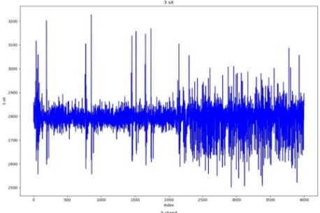

## B.DATASET

This study utilized a dataset comprising sEMG signals collected from 22 individuals, split evenly between those with healthy knees (11 participants) and those diagnosed with knee abnormalities (11 participants) . The sEMG signals were gathered from four key muscles surrounding the knee joint: the rectus femoris, vastus medialis, biceps femoris, and semitendinosus, during three specific activities—walking, standing, and sitting .

The muscle activity was measured using a Muscle BioAmp Candy sensor connected to an ESP32 microcontroller. Data was recorded at a 500 Hz sampling rate, with the collected information transmitted to the cloud via the ThingSpeak platform, enabling both real-time monitoring and data storage .

## C.Methodology

### 1. Hardware Setup

The hardware configuration for this study involved the use of the ESP32 microcontroller alongside the Muscle BioAmp Candy sensor. The ESP32, equipped with dual-core processors and built-in Wi-Fi/Bluetooth capabilities, proved optimal for collecting and transmitting sEMG data in real time. Muscle activity was recorded via surface electrodes connected to the Muscle BioAmp Candy sensor, providing an affordable and portable solution for continuous sEMG data acquisition [2].

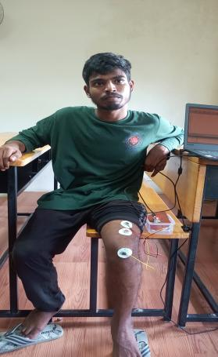

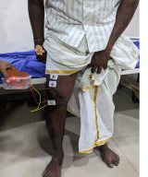

***Fig-1a: Abnormal Subject Fig-1b: Normal Subject***

### 2.Data acquisition

sEMG signals were collected as participants engaged in activities such as walking, standing, and sitting. The Muscle BioAmp Candy sensor, interfaced with the ESP32 microcontroller, captured the muscle signals at a sampling rate of 500 Hz. This data was then sent to the ThingSpeak platform, enabling both real-time visualization and secure cloud-based storage [3,5].

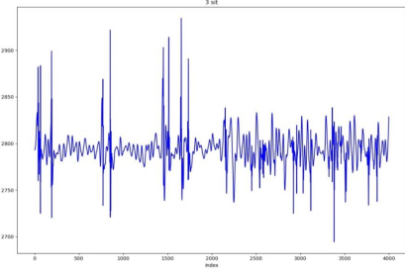

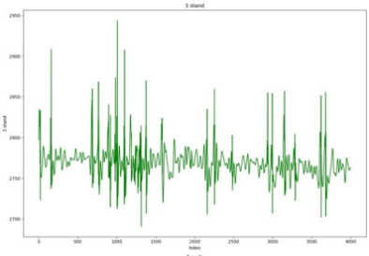

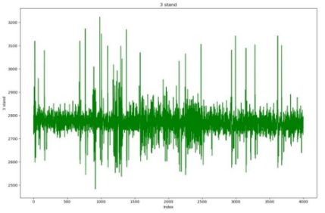

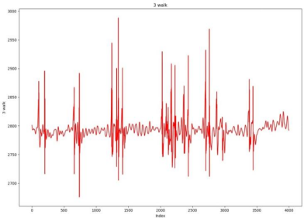

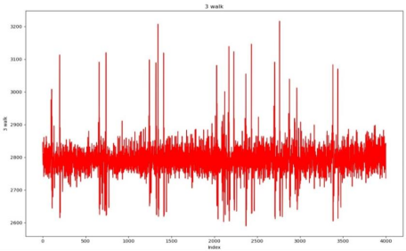

***Fig-a Fig-B***

### ***Fig. 2: sEMG signals captured during three different activities: Sittin, Standing, and Walking.***

### ***The figures illustrates the signal (a) Raw Signal (b) After applying the denoising proces(DWT)***

### 3.Preprocessing and Denoising

To improve the clarity of the raw sEMG data, a series of preprocessing steps were applied, focusing on noise reduction. The Discrete Wavelet Transform (DWT) was utilized for signal denoising, allowing for a multi-level decomposition that effectively filtered out noise while retaining the essential signal components. The Daubechies wavelet (level four) was selected due to its compatibility with biomedical signal processing [1,3]. Additionally, the data was segmented into 45ms windows with a 25% overlap.

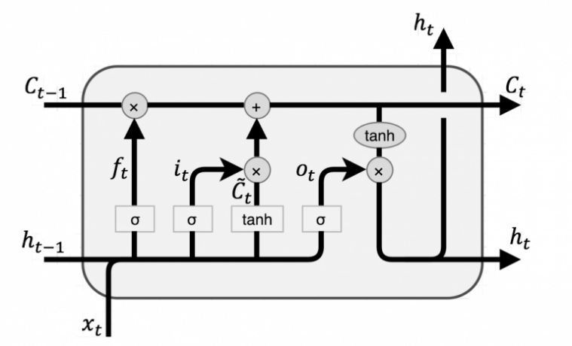

***Fig-3: LSTM Cell***

4.LSTM Architecture

The deep learning model employed in this study was built upon the Long Short-Term Memory (LSTM) network, specifically designed to capture and model temporal dependencies in sequential data. The architecture included two LSTM layers, followed by batch normalization to stabilize training. Each input consisted of 45ms segments of sEMG data, which were processed through the LSTM layers to detect temporal patterns in muscle activity.

Long Short-Term Memory (LSTM) networks are specifically designed to handle the issue of long-term dependencies within sequential data. Each LSTM cell consists of a cell state . It has 3 gates(input, output and forgot gate ). LSTM will receive the recent data input xj and the previous implicit state ht-1 and the memory cell state Ct-1 through the forgetting gate, input gate and output gate. The LSTM computational mechanism is shown below. Through the forgetting gate ft to determine which of the current data messages should be deleted from the memory cell state.



Using the input gate it to decide the new messages to be stored in the new single page state



Where gt represents the candidate value to be added to the new cell state. The impact of Ct−1 *ft is to determine how much information will be removed from Ct−1 (forgotten) and how many messages will be added to the new cell state of C t. Using the output gate, calculate ht:



Where : σ and ϕ are respectively functioned by the sigmoid and tanh activation. Wfx, Wfh, Wix , Wih, Wgx, Wgh, Wox, Woh are respectively the forgot gate,input gate, output gate and input Xt and the previously implied state ht−1 the matrix of weights multiplied by each other.bf, bt, bg, bo are the corresponding bias coefficients; and f t, i t, g t, ot , C t, h t are respectively the output results of forgetting gate, input gate, input node, output gate, memory cell state and implicit state.

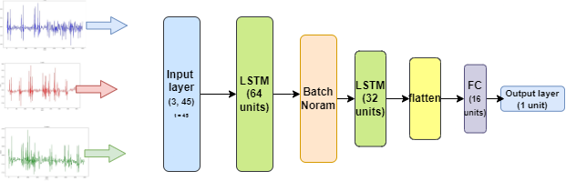

***Fig-3: Model Architecture***

### 5.Training Process

The training of the model was conducted within a Google Colab environment equipped with 12GB of RAM and Tesla T4 GPUs. The optimization process utilized the RMSProp algorithm, Throughout the training process, the RMSprop algorithm continuously modifies the network's weights by adjusting the learning rates according to the moving average of squared gradients. This technique allows each parameter to adapt its learning rate individually, promoting faster convergence and enhancing overall training stability. Training was performed for 30 epochs with a constant learning rate of 0.001 and a batch size of 16. Early stopping was employed to mitigate overfitting, halting the training when no further improvement in validation loss was detected after a specified number of epochs, promoting enhanced generalization.

The dataset was systematically divided into training (80%) and testing (20%) subsets, employing stratified sampling to ensure a balanced representation across classes. Training was performed on the LSTM model using the training dataset, while the evaluation of the model's performance was conducted through metrics including accuracy, precision, recall, and F1-score. These metrics were selected to provide a thorough evaluation of the classification capabilities of the model, particularly in light of the dataset's imbalanced characteristics [3]. Additionally, cross-validation techniques were employed during training to find best hyperparameters, thereby enhancing the model's ability to generalize effectively to unseen data.

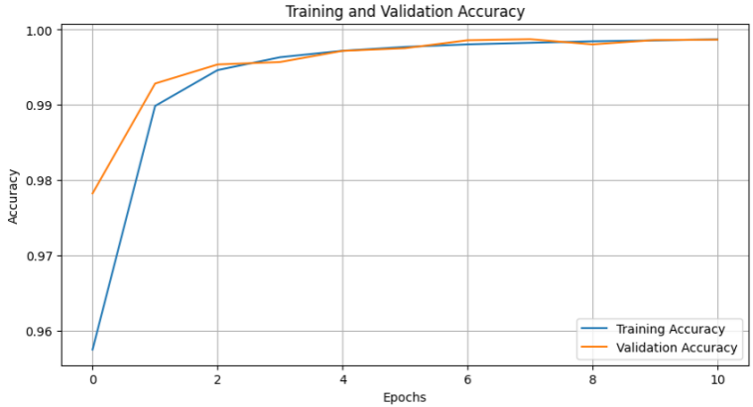

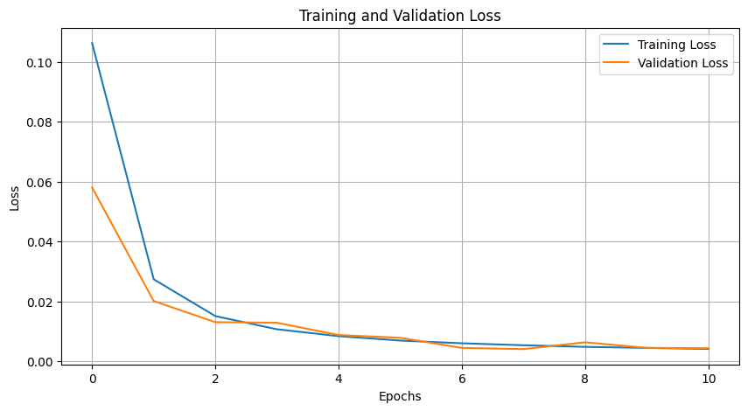

*Fig- 4(a), 4(b),: Graphs in Training ,Validation in Epochs*

*Vs Loss,accuracy*

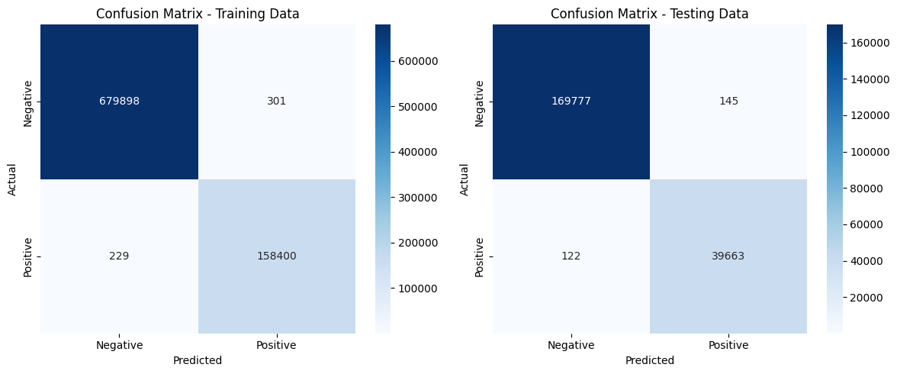

**

*Fig - 5(a), 5(b) Confusion matrix on training data and testing data*

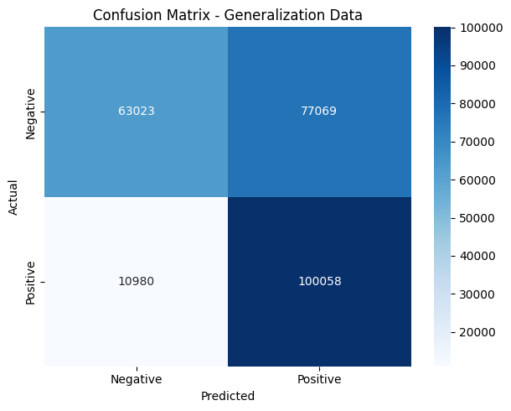

*Fig - 5(c) Confusion matrix on Generalization data (Our collected data)*

### 6. Performance Evaluation

The model's performance was evaluated based on its ability to accurately classify normal and abnormal knee conditions. The primary evaluation metric was accuracy, but precision and recall were also emphasized to account for the potential imbalance between the number of normal and abnormal cases in the dataset. The LSTM model achieved higher performance metrics compared to traditional machine learning classifiers, demonstrating its ability to effectively process sEMG signals for knee abnormality detection[1,3].

# **RESULTS AND DISCUSSION**

## Performance Comparison

The proposed Long Short-Term Memory (LSTM) model for knee abnormality detection was evaluated using a set of standard metrics, including accuracy, precision, recall, and F1-score. These metrics provided insights into the model's ability to correctly classify knee abnormalities based on surface electromyography (sEMG) signals.

In previous work, several machine learning models were tested for the same task, including k-Nearest Neighbors (KNN), Support Vector Machine (SVM), Decision Tree, Random Forest, and Extra Trees classifiers. Among these, the Extra Trees classifier achieved the highest accuracy of 91%, which set a strong baseline for comparison [1].

In contrast, the LSTM model, trained on sequential sEMG data, demonstrated superior performance due to its ability to capture temporal dependencies in the signals. The LSTM model achieved an accuracy of 99.8%, outperforming all traditional machine learning models. The precision and recall scores were also higher for the LSTM model, with a precision of 99.74% and a recall of 99.56%. This resulted in an F1-score of 99.65% reflecting the model’s balanced performance across these critical metrics.our model outperformed with a 64% accuracy on our collected real-time data.

The comparison of model performances is summarized in Table I below:

| **Models** | **Accuracy (%)** | **Precision (%)** | **Recall (%)** | **F1-Score (%)** |
| --- | --- | --- | --- | --- |
| KNN | 85.3 | 84.9 | 85.7 | 85.3 |
| SVM | 87.2 | 86.8 | 87.5 | 87.1 |
| Decision Tree | 88.0 | 87.6 | 88.3 | 88.0 |
| Random Forest | 89.5 | 89.2 | 89.7 | 89.4 |
| Extra Trees | 91.0 | 90.8 | 91.2 | 91.0 |
| **LSTM** | **99.8** | **99.74** | **99.56** | **99.65.** |

### B. Significance of Findings

The results demonstrate the clear advantage of using deep learning models, particularly LSTM networks, over traditional machine learning approaches for knee abnormality detection using sEMG signals. The sequential nature of sEMG signals, which reflect muscle activity over time, is crucial for accurate diagnosis. LSTM networks are particularly well-suited for this task as they can effectively learn long-term dependencies in time-series data, whereas traditional classifiers like KNN or SVM process each data point in isolation [1,3].

Additionally, the Extra Trees classifier, though accurate at 91%, lacks the temporal analysis capabilities of LSTM networks. By incorporating memory into its architecture, the LSTM can capture patterns that extend beyond individual time windows, resulting in improved performance across all evaluation metrics [3].

### C. Comparison with Traditional Diagnostic Methods

Compared to traditional diagnostic methods such as Magnetic Resonance Imaging (MRI) and X-ray, the proposed sEMG-based LSTM model offers a non-invasive, cost-effective, and real-time alternative. While MRI provides detailed imaging of knee structures, it is expensive and not always accessible in resource-limited settings. The LSTM model, on the other hand, can process real-time sEMG data and deliver immediate results, making it an ideal tool for early detection of knee abnormalities, especially in settings where MRI is impractical [2].

The incorporation of deep learning in sEMG signal processing opens up new possibilities for wearable diagnostics, where real-time analysis can be performed on embedded systems. This approach not only enhances accessibility but also has the potential to revolutionize the way knee abnormalities are detected and monitored over time.

## D.Visualizations

Table I below presents a comparison of model performance across different classifiers. It highlights the LSTM model’s superior accuracy and F1-score, making it a more reliable solution for knee abnormality detection

## **IV. CONCLUSION**

In this study, we introduced a non-invasive and cost-effective method for diagnosing knee abnormalities in older adults by analyzing surface EMG (sEMG) signals during gait, standing, and sitting activities. Our methodology encompassed data acquisition, preprocessing, feature selection, and the training of a Long Short-Term Memory (LSTM) model on sEMG data from 22 subjects. Following this, the model was tested on clinical data. The findings demonstrate that the LSTM model efficiently detects knee abnormalities, achieving a generalization accuracy of 64.9% on unseen clinical data. These results highlight the potential of sEMG-based diagnostics as a viable and affordable alternative to more expensive imaging methods such as MRI, showing promise in healthcare applications.

REFERENCES

#### [1] A. Vijayvargiya, R. Kumar, N. Dey, J. M. Tavares, "Comparative Analysis of Machine Learning Techniques for the Classification of Knee Abnormality," in 2020 IEEE 5th International Conference on Computing Communication and Automation, Greater Noida, UP, India, Oct. 2020.

#### [2] Vijayvargiya et al., "Hardware Implementation for Lower LimbSurface EMG Measurement and Analysis Using Explainable AI for Activity Recognition," in IEEE Transactions on Instrumentation and Measurement, vol. 71, 2022.

#### [3] Vijayvargiya et al., "sEMG-based Deep Learning Framework for the Automatic Detection of Knee Abnormality," in Signal, Image and Video Processing, vol. 17, 2023.

#### [4] P. Tokas, V. B. Semwal, et al., “Deep Ensemble Learning Approach for Lower Limb Movement Recognition from Multichannel sEMG Signals,” Neural Computing and Applications, 2024.

#### [5] A. Vijayvargiya, R. Kumar, and P. Sharma, “PC-GNN: Pearson Correlation-Based Graph Neural Network for Recognition of Human Lower Limb Activity Using sEMG Signal,” IEEE Trans. on Human- Machine Systems, 2023.

#### [6] S. Hochreiter and J. Schmidhuber, “Long Short-Term Memory,” Neural Computation, vol. 9, pp. 1735-1780, 1997​(Long Short-Term Memory).

#### [7] T. Chen and C. Guestrin, "XGBoost: A scalable tree boosting system," in Proc. 22nd ACM SIGKDD Int. Conf. Knowledge Discovery and Data Mining, 2016, pp. 785-794.

#### [8] A. Krizhevsky, I. Sutskever, and G. E. Hinton, "ImageNet classification with deep convolutional neural networks," Commun. ACM, vol. 60, no. 6, pp. 84-90, 2017.

#### [9] A. Graves, S. Fernández, and F. Gomez, "Connectionist temporal classification: Labelling unsegmented sequence data with recurrent neural networks," in Proc. 23rd Int. Conf. Machine Learning, 2006, pp. 369-376.

#### [10] J. Schmidhuber, "Deep learning in neural networks: An overview," Neural Networks, vol. 61, pp. 85-117, 2015.

#### [11] K. He, X. Zhang, S. Ren, and J. Sun, "Deep residual learning for image recognition," in Proc. IEEE Conf. Computer Vision and Pattern Recognition, 2016, pp. 770-778.

#### [12] I. Sutskever, O. Vinyals, and Q. V. Le, "Sequence to sequence learning with neural networks," in Advances in Neural Information Processing Systems, 2014, pp. 3104-3112.

#### [13] T. N. Kipf and M. Welling, "Semi-supervised classification with graph convolutional networks," in Proc. Int. Conf. Learning Representations, 2016.

#### [14] D. Erhan et al., "Visualizing higher-layer features of a deep network," Univ. Toronto, Toronto, ON, Canada, Tech. Rep. 1341, 2009.

#### [15] H. J. Hermens et al., "Development of recommendations for SEMG sensors and sensor placement procedures," J. Electromyogram. Kinesiol.vol. 10, no. 5, pp. 361-374, 2000.

#### [16] Y. LeCun et al., "Deep learning," Nature, vol. 521, no. 7553, pp. 436-444, 2015.

#### [17] K. Cho et al., "Learning phrase representations using RNN encoder- decoder for statistical machine translation," in Proc. 2014 Conf. Empirical Methods in Natural Language Processing, 2014, pp. 1724-1734.

1. .